**This Document is to show you how to upload more than 100mb on GitHub.**

1. **Download Git. Don’t change any option during the installation except the default editor for Git if you want.**[**https://git-scm.com/downloads**](https://git-scm.com/downloads)
2. **Download Git LFS**[**https://git-lfs.com/**](https://git-lfs.com/)
3. **Download GitHub Desktop**[**https://desktop.github.com/**](https://desktop.github.com/)
4. **Clone the repository on GitHub desktop.  
   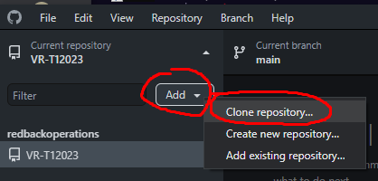**

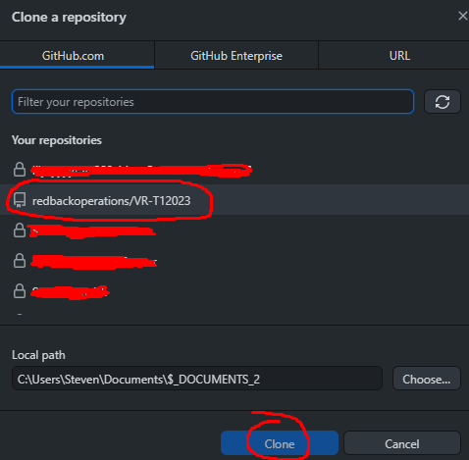

**Now you can Open the Explorer**

1. **Right click on the Explorer file  
   Graphical user interface

   Description automatically generated**
2. **Click on Git Bash Here  
   Graphical user interface

   Description automatically generated with low confidence**
3. **Mingw64 will open and write the command: git lfs install**

1. **Open the Unity Project and make sure the project is “Force Text”  
   Graphical user interface, text, application

   Description automatically generated**
2. **Now we want Git LFS to track files that can be over 100mb. For now, we use .psd (If .gitattributes already exist. Probably you won’t have to do this part)  
   Text

   Description automatically generated**
3. **A new file will be created that tracks the specified files.  
   Graphical user interface, text, application

   Description automatically generated**
4. **Now when you try to commit a new change to the project and a file is over 100mb. Check its file extension.  
   Text

   Description automatically generated**

**12. Open .gitattribrutes and write this code  
**

1. **Now Commit .gitattributes first and then commit the change that was more than 100mb**
2. **This code will show all the files that have been track by Git LFS  
     
   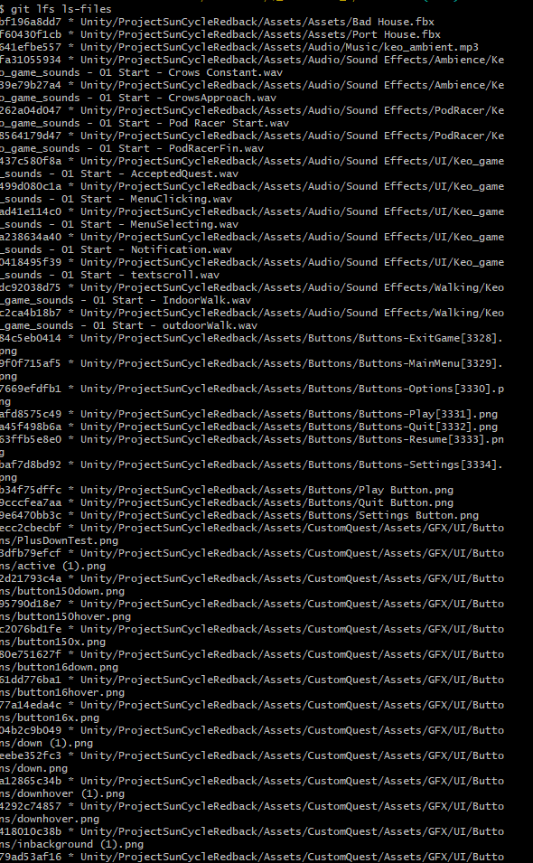**

**Now you should be able to upload more than 100mb**